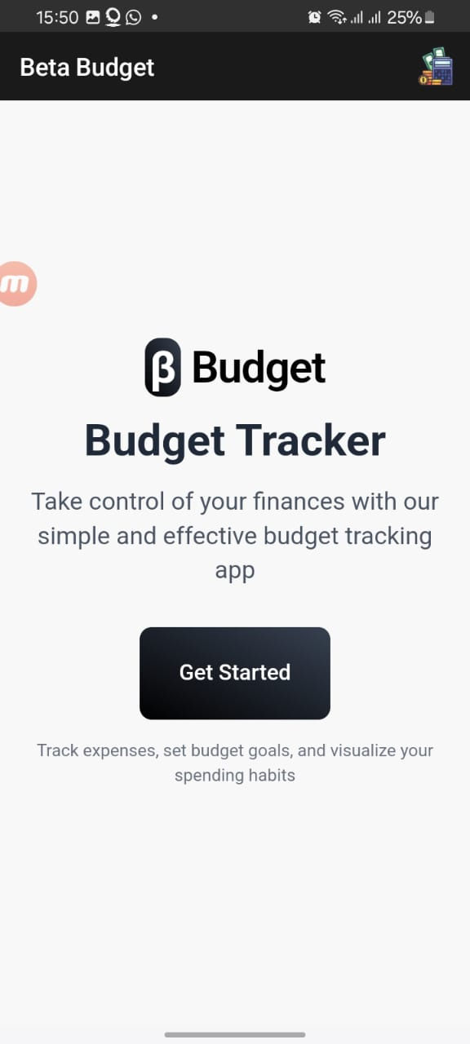

A mobile app interface for a budgeting application is shown. The app's title, "Budget Tracker," is displayed prominently. A subheading describes the app as providing a simple and effective way to track finances. Below the title, there is a button that reads "Get Started". Below that, additional text describes the app's features as tracking expenses, setting budget goals, and visualizing spending habits. A logo of the app, stylized as a "B" for Beta, is visible.

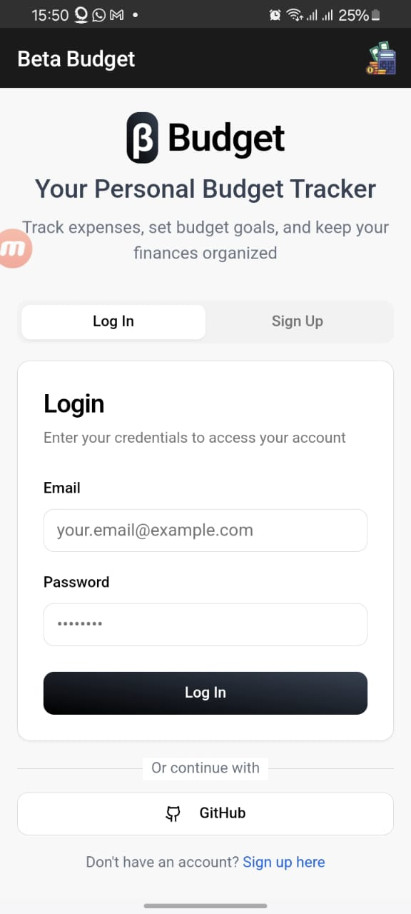

The "Beta Budget" mobile app interface is shown. The name "Beta Budget" and a tiny icon are displayed in the app's header. Below that, a logo with the word "Budget" and the letter "B" enclosed in a picture that looks like a budget or money symbol. "Your Personal Budget Tracker," a subtitle, and a brief explanation of the app's purpose are then displayed.   
  
A login form appears in the middle of the screen. Above a text box for the email address, which is currently filled in with "your.email@example.com," the word "Login" is prominently displayed. A password field hidden by asterisks is located beneath this. There are buttons to sign up and log in. There is also a backup way to log in using GitHub. Users are redirected to the app's signup page by a "Don't have an account?" link.

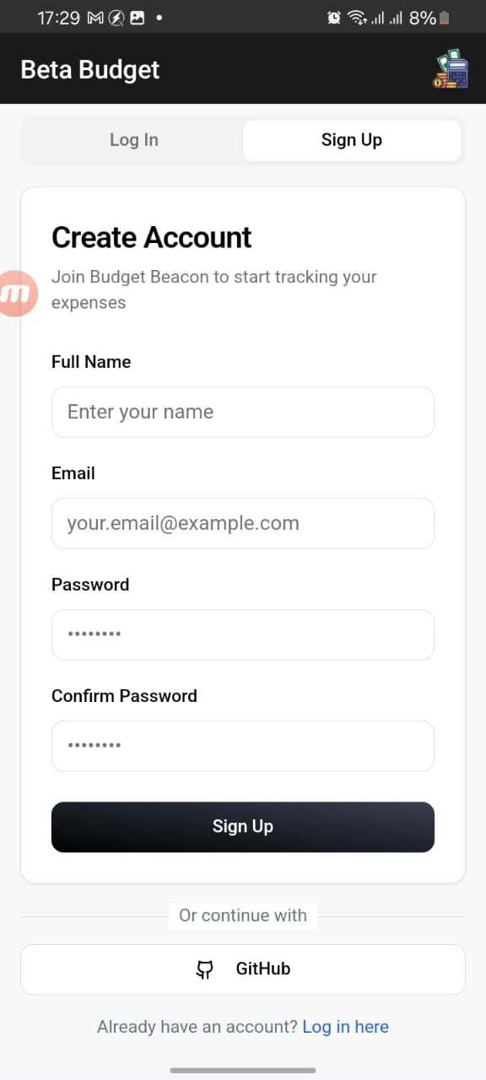

The "Sign Up" interface for the "Beta Budget" app is displayed on a mobile phone's screen. A black navigation bar at the top of the screen displays the time, "17:29," along with indicators for mobile connectivity and a battery icon that indicates 8% charge. The title "Beta Budget" appears below, followed by two buttons that read "Log In" and "Sign Up," with the latter button being highlighted.

The "Create Account" form in the main content area invites users to sign up for "Budget Beacon" so they can keep tabs on their spending. The user must enter their "Full Name," which is shown as a text field with the placeholder "Enter your name." Following this are three fields that are filled with obscured text: "Email" with the placeholder "your.email@example.com," "Password," and "Confirm Password." Below the form fields is a large, dark "Sign Up" button.

There is a button with the GitHub logo to the left of the text that indicates the option to continue with "GitHub," which is located beneath the "Sign Up" button. Users who have already registered are prompted to log in by a line that reads, "Already have an account?" at the bottom of the screen in a smaller font. This is followed by a link that reads, "Log in here." In the top right corner are icons of money stacks, money rolls, and a calculator.

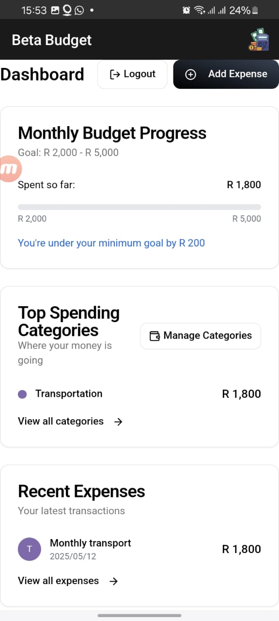

It shows the interface of a mobile app, probably for budgeting. The "Monthly Budget Progress" is displayed in the "Dashboard," the top section. Out of a target of R 2,000 to R 5,000, the progress bar shows that R 1,800 has been spent. "You're under your minimum goal by R 200," reads the message.

The "Top Spending Categories" section below this shows that, with R 1,800 spent, "Transportation" is the largest category.   
  
"Monthly transport" on 2025/05/12, with an expense of R 1,800, is the only entry in the "Recent Expenses" section.   
  
You can see the "Logout," "Add Expense," and "Manage Categories" buttons. The interface has a light color scheme and is tidy. The 2025/05/12 date format is noteworthy.

The screen of a mobile app, most likely "Beta Budget," which is a budgeting app, shows the "Manage Categories" section. Existing expense categories are listed in this section, such as "Food," "Transportation," "Entertainment," and "Shopping."

A pencil icon and a trash can icon, respectively, indicate the ability to edit or remove a category. Each category has a colored icon, such as an orange circle for shopping, a purple square for transportation, a purple circle for food, and a light blue circle for entertainment.

The user can create a new expense category by clicking the "Add New Category" button. Buttons labeled "Dashboard," "Add," "Expenses," "Goals," and "Reports" run along the bottom of the screen, indicating that the app has more features related to financial management and budgeting. The battery life is 24%, as shown in the upper right corner.

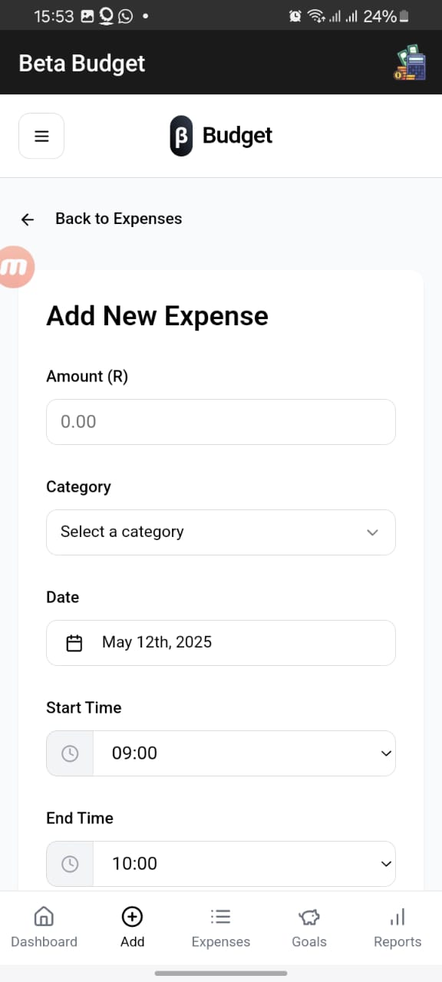

A screen from a mobile application showing a form to add a new expense. "Add New Expense" is the title. There are fields to enter the amount (which is currently displayed as "0.00"), category (which has a dropdown menu labeled "Select a category"), date (which displays as "May 12th, 2025"), start time (which displays as "09:00"), and end time (which displays as "10:00"). "Beta Budget" and a budget icon are shown in the application's header.

Description: A text field for expense notes.   
Add a photo (optional): A photo upload section (up to 5MB, PNG, JPG, or JPEG).   
The buttons below the form are for:   
  
Cancel: to remove the entry.   
Include Expense: to store the data that was entered.

At the bottom of the screen are buttons labeled "Dashboard," "Add," "Expenses," "Goals," and "Reports." It looks like the app is for tracking personal finances.

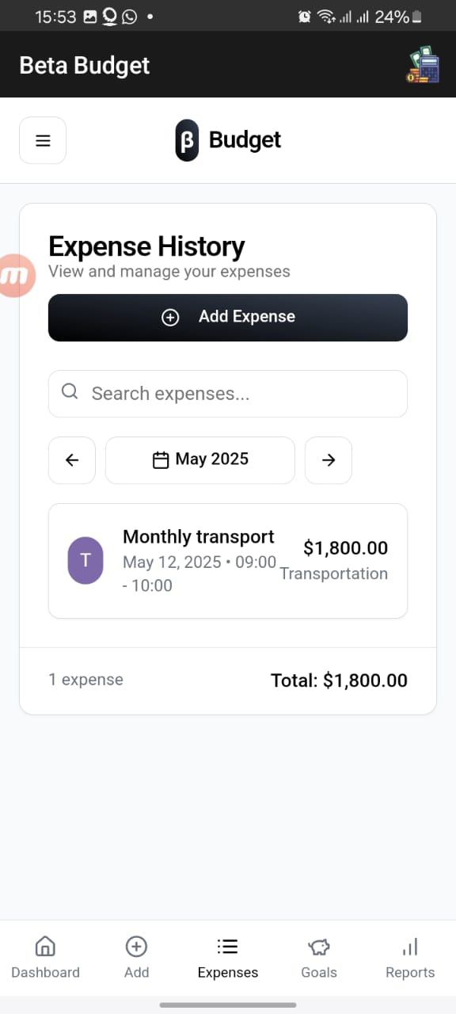

The screenshot shows the "Beta Budget" mobile app's expense history screen. The app name and logo are displayed at the top of the screen banner. A button labeled "Add Expense" appears beneath the title "Expense History," which is followed by the subtitle "View and manage your expenses." A search bar with the placeholder text "Search expenses..." appears beneath the Expense History.

With the "Left Arrow" and "Right Arrow" navigation buttons on either side, the screen is showing the May 2025 spending history. The information for the "Monthly transport" is shown on a card: the expenditure, which is classified as "Transportation," totaled $1,800.00 and was made on May 12, 2025, between 9:00 and 10:00. "1 expense" and "Total: $1,800.00" are displayed in the lower portion of the screen. Users can navigate between "Dashboard," "Add," "Expenses," "Goals," and "Reports" using the bottom navigation bar.

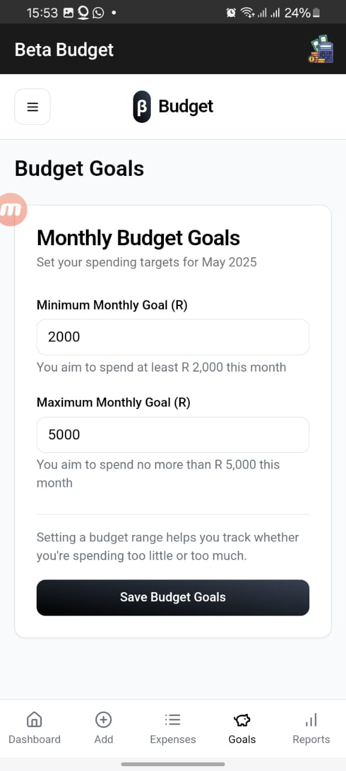

The screenshot shows the "Beta Budget" app's "Monthly Budget Goals" interface, which is customized for May 2025.   
  
The app's logo, which is centered at the top, consists of the stylized "ß" symbol and the words "Budget." "Budget Goals" is prominently displayed in the header below, followed by the "Monthly Budget Goals" section.   
  
Users are asked to set spending goals in this section. "Minimum Monthly Goal (R)" and "Maximum Monthly Goal (R)" are the two main fields that are accessible. The accompanying text reads, "You aim to spend at least R 2,000 this month," and the minimum goal is currently set at "2000." Likewise, the text states, "You aim to spend no more than R 5,000 this month," with "5000" as the maximum goal.

The advantages of establishing a budget range are highlighted in a descriptive paragraph, which also explains how it enables users to monitor whether they are spending too much or too little.   
  
To enable users to save their settings, a noticeable "Save Budget Goals" button is placed.

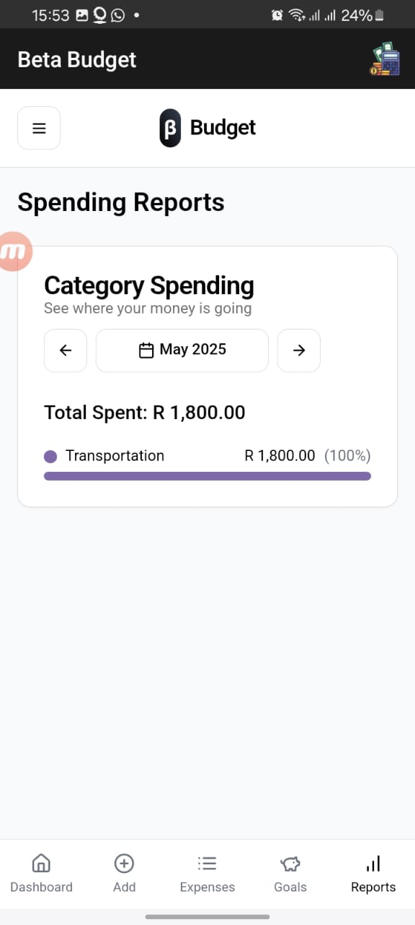

Given the battery and wireless status icons at the top, the screenshot shows a "Spending Reports" screen inside the "Beta Budget" application, most likely on a mobile device.   
  
There is a clear display of the "Category Spending" section. "See where your money is going" is one of the texts that encourages users to examine their spending patterns. A date picker set to May 2025 is bookended by navigation arrows. "R 1,800.00" is the total amount shown as spent, where "R" most likely stands for the South African Rand.   
  
A thorough breakdown by category can be found beneath the total spending. At the moment, the only category mentioned is "Transportation," which represents "R 1,800.00," or 100% of the total expenditure. A purple bar that spans the width of its designated space serves as a visual representation of this.